**INDIA GENERAL ELECTIONS RESULT ANALYSIS 2024**

**1.Total Seats**

Select

Distinct Count(Parliament_Constituency) Total_Seats

From

constituencywise_results



**2.What is the total number of seats available for elections in each state**

Select

s.State State_Name,

Count(cr.Constituency_ID) As Total_Seats_Available

From

constituencywise_results cr

Inner Join

statewise_results sr On cr.Parliament_Constituency = sr.Parliament_Constituency

Inner Join

states s On sr.State_ID = s.State_ID

Group By

s.State

Order By

s.State

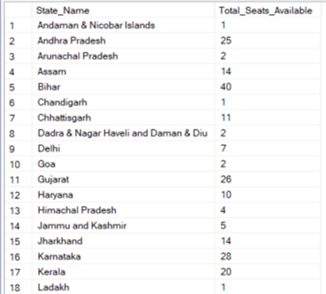 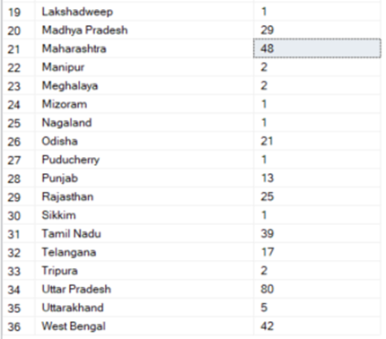

**3.Total Seats Won by NDA Allianz**

Select

Count(Parliament_Constituency) NDA_Total_Seats_Won

From

constituencywise_results cr

Inner Join

partywise_results pr On cr.Party_ID = pr.Party_ID

Where Party In (

'Bharatiya Janata Party - BJP',

'Telugu Desam - TDP',

'Janata Dal (United) - JD(U)',

'Shiv Sena - SHS',

'AJSU Party - AJSUP',

'Apna Dal (Soneylal) - ADAL',

'Asom Gana Parishad - AGP',

'Hindustani Awam Morcha (Secular) - HAMS',

'Janasena Party - JnP',

'Janata Dal (Secular) - JD(S)',

'Lok Janshakti Party(Ram Vilas) - LJPRV',

'Nationalist Congress Party - NCP',

'Rashtriya Lok Dal - RLD',

'Sikkim Krantikari Morcha - SKM'

)

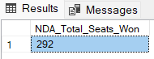

**4.Seats Won by NDA Allianz Parties**

Select

Party As Party_Name,

Won As Seats_Won

From

partywise_results

Where Party In (

'Bharatiya Janata Party - BJP',

'Telugu Desam - TDP',

'Janata Dal (United) - JD(U)',

'Shiv Sena - SHS',

'AJSU Party - AJSUP',

'Apna Dal (Soneylal) - ADAL',

'Asom Gana Parishad - AGP',

'Hindustani Awam Morcha (Secular) - HAMS',

'Janasena Party - JnP',

'Janata Dal (Secular) - JD(S)',

'Lok Janshakti Party(Ram Vilas) - LJPRV',

'Nationalist Congress Party - NCP',

'Rashtriya Lok Dal - RLD',

'Sikkim Krantikari Morcha - SKM'

)

Order By

Seats_Won desc

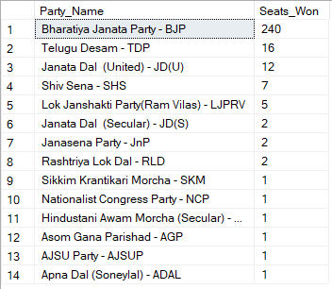

**5.Total Seats Won by I.N.D.I.A. Allianz**

Select

Count(cr.Parliament_Constituency) INDIA_Total_Seats_Won

From

constituencywise_results cr

Inner Join

partywise_results pr

On

cr.Party_ID = pr.Party_ID

Where Party In (

'Indian National Congress - INC',

'Aam Aadmi Party - AAAP',

'All India Trinamool Congress - AITC',

'Bharat Adivasi Party - BHRTADVSIP',

'Communist Party of India (Marxist) - CPI(M)',

'Communist Party of India (Marxist-Leninist) (Liberation) - CPI(ML)(L)',

'Communist Party of India - CPI',

'Dravida Munnetra Kazhagam - DMK',

'Indian Union Muslim League - IUML',

'Nat`Jammu & Kashmir National Conference - JKN',

'Jharkhand Mukti Morcha - JMM',

'Jammu & Kashmir National Conference - JKN',

'Kerala Congress - KEC',

'Marumalarchi Dravida Munnetra Kazhagam - MDMK',

'Nationalist Congress Party Sharadchandra Pawar - NCPSP',

'Rashtriya Janata Dal - RJD',

'Rashtriya Loktantrik Party - RLTP',

'Revolutionary Socialist Party - RSP',

'Samajwadi Party - SP',

'Shiv Sena (Uddhav Balasaheb Thackrey) - SHSUBT',

'Viduthalai Chiruthaigal Katchi - VCK'

)

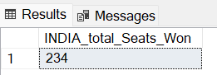

**6.Seats Won by I.N.D.I.A. Allianz Parties**

Select

Party Party_Name,

Won Seats_Won

From

partywise_results

Where

Party In (

'Indian National Congress - INC',

'Aam Aadmi Party - AAAP',

'All India Trinamool Congress - AITC',

'Bharat Adivasi Party - BHRTADVSIP',

'Communist Party of India (Marxist) - CPI(M)',

'Communist Party of India (Marxist-Leninist) (Liberation) - CPI(ML)(L)',

'Communist Party of India - CPI',

'Dravida Munnetra Kazhagam - DMK',

'Indian Union Muslim League - IUML',

'Nat`Jammu & Kashmir National Conference - JKN',

'Jharkhand Mukti Morcha - JMM',

'Jammu & Kashmir National Conference - JKN',

'Kerala Congress - KEC',

'Marumalarchi Dravida Munnetra Kazhagam - MDMK',

'Nationalist Congress Party Sharadchandra Pawar - NCPSP',

'Rashtriya Janata Dal - RJD',

'Rashtriya Loktantrik Party - RLTP',

'Revolutionary Socialist Party - RSP',

'Samajwadi Party - SP',

'Shiv Sena (Uddhav Balasaheb Thackrey) - SHSUBT',

'Viduthalai Chiruthaigal Katchi - VCK'

)

Order By Seats_Won Desc

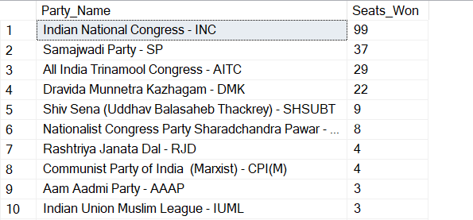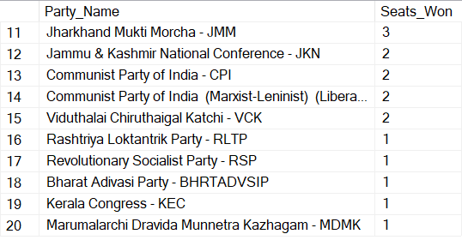

**7.Add new column field in table partywise_results to get the Party Allianz as NDA, I.N.D.I.A and OTHER**

Select *

From partywise_results

--Add New Column

Alter Table partywise_results

Add Party_alliance Varchar(50)

--NDA Alliance

Update

partywise_results

Set

Party_alliance = 'NDA'

Where

Party In (

'Bharatiya Janata Party - BJP',

'Telugu Desam - TDP',

'Janata Dal (United) - JD(U)',

'Shiv Sena - SHS',

'AJSU Party - AJSUP',

'Apna Dal (Soneylal) - ADAL',

'Asom Gana Parishad - AGP',

'Hindustani Awam Morcha (Secular) - HAMS',

'Janasena Party - JnP',

'Janata Dal (Secular) - JD(S)',

'Lok Janshakti Party(Ram Vilas) - LJPRV',

'Nationalist Congress Party - NCP',

'Rashtriya Lok Dal - RLD',

'Sikkim Krantikari Morcha - SKM'

)

--INDIA Alliance

Update

partywise_results

Set

Party_alliance = 'I.N.D.I.A'

Where

Party In (

'Indian National Congress - INC',

'Aam Aadmi Party - AAAP',

'All India Trinamool Congress - AITC',

'Bharat Adivasi Party - BHRTADVSIP',

'Communist Party of India (Marxist) - CPI(M)',

'Communist Party of India (Marxist-Leninist) (Liberation) - CPI(ML)(L)',

'Communist Party of India - CPI',

'Dravida Munnetra Kazhagam - DMK',

'Indian Union Muslim League - IUML',

'Jammu & Kashmir National Conference - JKN',

'Jharkhand Mukti Morcha - JMM',

'Kerala Congress - KEC',

'Marumalarchi Dravida Munnetra Kazhagam - MDMK',

'Nationalist Congress Party Sharadchandra Pawar - NCPSP',

'Rashtriya Janata Dal - RJD',

'Rashtriya Loktantrik Party - RLTP',

'Revolutionary Socialist Party - RSP',

'Samajwadi Party - SP',

'Shiv Sena (Uddhav Balasaheb Thackrey) - SHSUBT',

'Viduthalai Chiruthaigal Katchi - VCK'

)

--OTHER

Update

partywise_results

Set

Party_alliance = 'OTHER'

Where

Party_alliance Is NULL

**8.Which party alliance (NDA, I.N.D.I.A, or OTHER) won the most seats across all states?**

Select

pr.Party_alliance,

Count(cr.Constituency_Name) Seats_Won

From

constituencywise_results cr

Inner Join

partywise_results pr

On cr.Party_ID = pr.Party_ID

Group By

pr.Party_alliance

Order By

Seats_Won Desc

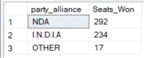

**9.Winning candidate's name, their party name, total votes, and the margin of victory for a specific state and constituency?**

Select

cr.Winning_Candidate,

pr.Party,

pr.Party_alliance,

cr.Total_Votes,

cr.Margin,

s.State,

cr.Constituency_Name

From

partywise_results pr

Inner Join

constituencywise_results cr

On cr.Party_ID = pr.Party_ID

Inner Join

statewise_results sr

On sr.Parliament_Constituency = cr.Parliament_Constituency

Inner Join

states s

On s.State_ID = sr.State_ID

Where

s.State = 'Andhra Pradesh' And cr.Constituency_Name = 'AMALAPURAM(SC)'



**10.What is the distribution of EVM votes versus postal votes for candidates in a specific constituency?**

Select

cd.Candidate,

cd.Party,

cd.EVM_Votes,

cd.Postal_Votes,

cd.Total_Votes,

cr.Constituency_Name

From

constituencywise_details cd

Inner Join

constituencywise_results cr

On cd.Constituency_ID = cr.Constituency_ID

Where

cr.Constituency_Name = 'AMALAPURAM(SC)'

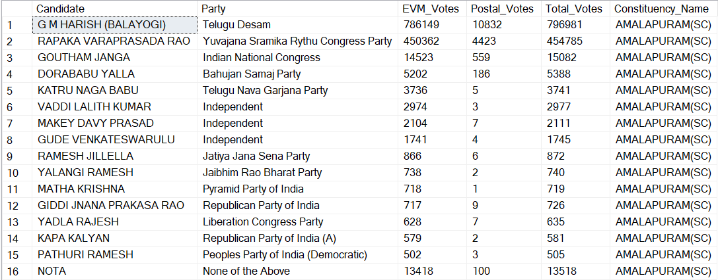

**11.Which parties won the most seats in s State, and how many seats did each party win?**

Select

pr.Party Party_Name,

Count( cr.Constituency_Name) Seats_Won

From

partywise_results pr

Inner Join

constituencywise_results cr

On cr.Party_ID = pr.Party_ID

Inner Join

statewise_results sr

On cr.Parliament_Constituency = sr.Parliament_Constituency

Inner Join

states s

On sr.State_ID = s.State_ID

Where

s.State = 'Andhra Pradesh'

Group By

pr.Party

Order By

Seats_Won Desc

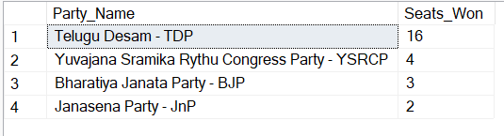

**12.What is the total number of seats won by each party alliance (NDA, I.N.D.I.A, and OTHER) in each state for the India Elections 2024**

select

State,

isnull([NDA],0) NDA_Won,

isnull([I.N.D.I.A],0) INDIA_Won,

isnull([OTHER],0) OTHER_Won

From(

Select

s.State,

pr.Party_alliance

From

partywise_results pr

inner join

constituencywise_results cr On pr.Party_ID = cr.Party_ID

inner join

statewise_results sr on cr.Parliament_Constituency = sr.Parliament_Constituency

inner join

states s On sr.State_ID = s.State_ID

) as sourcetable

Pivot

(Count(Party_alliance)

For Party_alliance In ([NDA],[I.N.D.I.A],[OTHER])

) AS PivotTable

**USING CTE**

With cte As (

Select

s.State,

pr.Party_alliance

From

partywise_results pr

Inner Join

constituencywise_results cr On pr.Party_ID = cr.Party_ID

Inner Join

statewise_results sr On cr.Parliament_Constituency = sr.Parliament_Constituency

Inner Join

states s On sr.State_ID = s.State_ID)

Select

State,

Isnull([NDA],0) NDA_Won,

Isnull([I.N.D.I.A],0) INDIA_Won,

Isnull([OTHER],0) OTHER_Won

From

cte

Pivot

(

Count(Party_alliance)

For Party_alliance In ([NDA],[I.N.D.I.A],[OTHER])

) As PivotTable

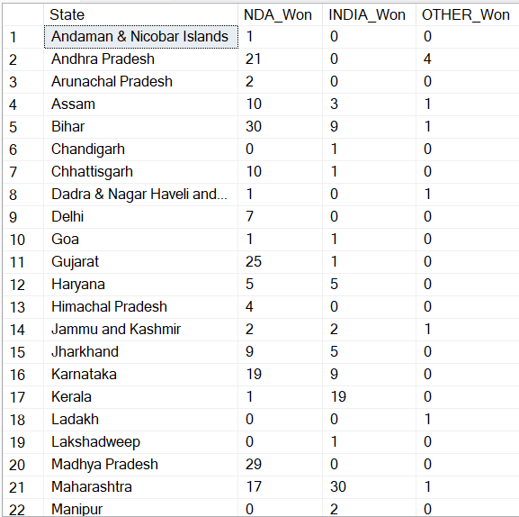

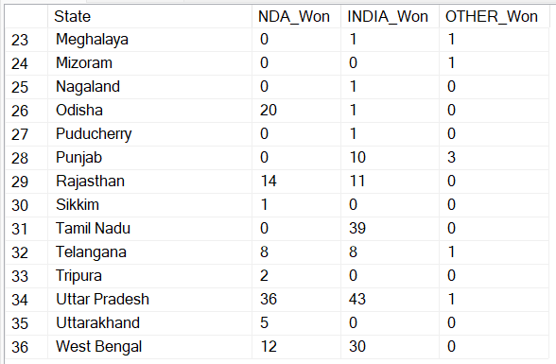

**13.Which candidate received the highest number of EVM votes in each constituency (Top 10)?**

Select Top 10

cr.Constituency_ID,

cr.Constituency_Name,

cd.Candidate Candidate_Name,

Max(cd.EVM_Votes) EVM_Votes

From

constituencywise_details cd

Inner Join

constituencywise_results cr On cd.Constituency_ID = cr.Constituency_ID

Group By

cd.Candidate,

cr.Constituency_ID,

cr.Constituency_Name

Order By

EVM_Votes desc

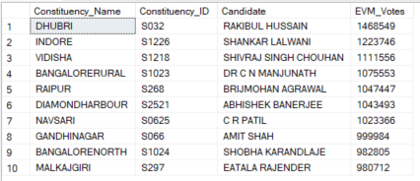

**14.Which candidate won and which candidate was the runner-up in each constituency of State for the 2024 elections?**

Select

Distinct cr.Constituency_Name,

sr.Leading_Candidate Winning_Candidate,

sr.Trailing_Candidate Runnerup_Candidate

From

constituencywise_details cd

Inner Join

constituencywise_results cr

On cd.Constituency_ID = cr.Constituency_ID

Inner Join

partywise_results pr

On cr.Party_ID = pr.Party_ID

Inner join

statewise_results sr

On cr.Parliament_Constituency = sr.Parliament_Constituency

Inner join

states s

On sr.State_ID = s.State_ID

Where

s.State = 'Andhra Pradesh'

Order By

cr.Constituency_Name

--Or

WITH RankedCandidates AS (

Select

cd.Constituency_ID,

cr.Constituency_Name,

cd.Candidate,

cd.Party,

cd.EVM_Votes,

cd.Postal_Votes,

cd.EVM_Votes + cd.Postal_Votes Total_Votes,

ROW_NUMBER() Over (Partition By cd.Constituency_ID Order By cd.EVM_Votes + cd.Postal_Votes Desc) Rnk

From

constituencywise_details cd

Inner join

constituencywise_results cr On cd.Constituency_ID = cr.Constituency_ID

Inner Join

statewise_results sr On cr.Parliament_Constituency = sr.Parliament_Constituency

Inner Join

states s On sr.State_ID = s.State_ID

Where

s.State = 'Andhra Pradesh'

)

Select

cr.Constituency_Name,

Max(Case When Rc.Rnk = 1 Then Rc.Candidate End) Winning_candidate,

Max(Case When Rc.Rnk = 2 Then Rc.Candidate End) Runnerup_candidate

From

RankedCandidates Rc

Inner Join

constituencywise_results cr On Rc.Constituency_ID = cr.Constituency_ID

Group By

cr.Constituency_Name

Order By

cr.Constituency_Name

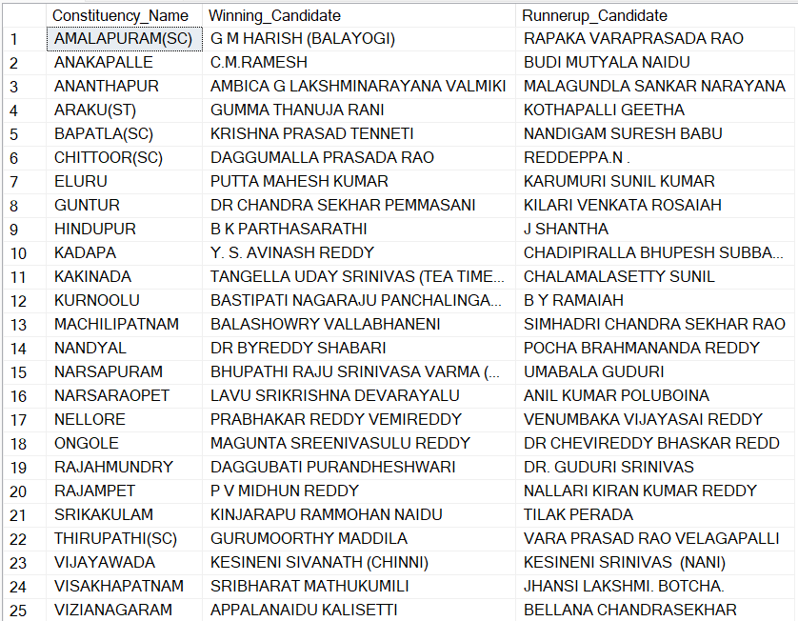

**15.For the state of AndhraPradesh, what are the total number of seats, total number of candidates, total number of parties, total votes (including EVM and postal), and the breakdown of EVM and postal votes?**

Select

s.state,

Count(Distinct cr.Parliament_Constituency) Total_Seats,

Count(Distinct cd.Candidate) Total_candidates,

Count(Distinct pr.Party) Total_Parties,

Sum(cd.EVM_Votes + cd.Postal_Votes) Total_Votes,

Sum(cd.EVM_Votes) Total_evm_Votes,

Sum(cd.Postal_Votes) Total_Postal_Votes

From

constituencywise_results cr

Inner Join

constituencywise_details cd On cr.Constituency_ID = cd.Constituency_ID

Inner Join

partywise_results pr On cr.Party_ID = pr.Party_ID

Inner Join

statewise_results sr On cr.Parliament_Constituency = sr.Parliament_Constituency

Inner Join

states s On sr.State_ID = s.State_ID

Where

s.State = 'Andhra Pradesh'

Group By

s.State

